First IRISE Brainstorming Session
On October 15, 2018, IRISE kicked off the planning process for its 2019 research program by conducting a brainstorming session on the University of Pittsburgh campus. Over 35 transportation engineering professionals from the public, private and academic sectors joined together to present and discuss highway transportation infrastructure problems, issues and research possibilities.
Dr. Radisav Vidic, the Chair of the Civil and Environmental Engineering Department, provided welcoming remarks and talked about the uniqueness of the public/private/academic collaboration and the availability of faculty from across the University to work on problems. IRISE Director Dr. Julie Vandenbossche then provided a briefing on IRISE and stressed its emphasis on producing implementable results relevant to member problems.
A wide range of problems and issues were presented and discussed by the public and private sector representatives, including those pertaining to understanding of infrastructure life cycle costs, structural health monitoring, performance of various types of pavement designs and overlays, bridge corrosion, landslide predictability, compliance with new stormwater requirements, reducing road closure time and many others. University of Pittsburgh faculty presented their qualifications and contributed additional research ideas. All of these ideas will be considered as IRISE works with its Steering Committee members to determine the research priorities over the coming months.
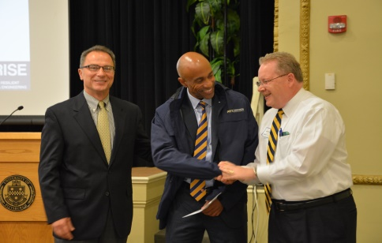
Jimmy Martin, the Dean of Pitt’s Swanson School of Engineering, also participated and made brief remarks that emphasized the importance of leadershrip. He received IRISE’s first member contribution from Allegheny County Manager William D. McKain. Mr. McKain stated, "I congratulate Pitt on its first IRISE meeting —-people were really engaged and the exchange of ideas and information provided a wonderful starting point for IRISE to build on and have great collaborations and meaningful outcomes."
Dr. Vandenbossche expressed her appreciation for the lively participation. "We particularly appreciated everyone's willingness to share ideas with each other. The exchange of information among different agencies and private organizations is exactly what the IRISE concept is trying to promote."

